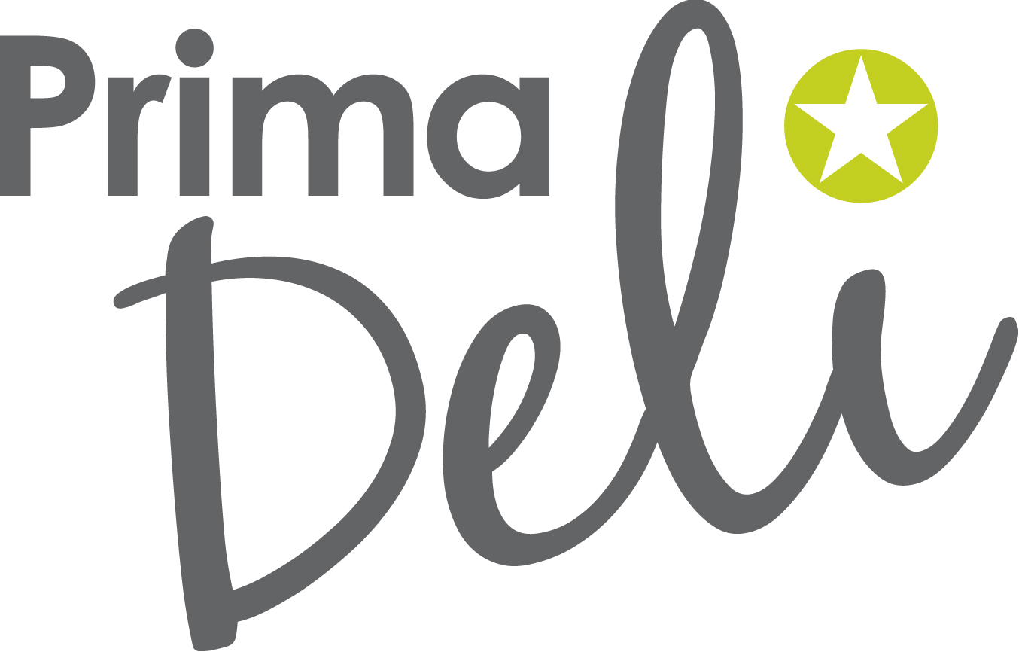
  13b Gabador Place,
  Mt Wellington, Auckland 1060
  PO Box 62-143, Sylvia Park, Auckland 1644
  t. 09.5731023 f. 09.5731025
  e. admin@primadelinorth.co.nz
APPLICATION FOR CREDIT

Company Name: |  | Date:
Trading Name (if different):
Proprietor Name(s):
Proprietor Residential Address:
Postal Address:
Delivery Address:
Phone: | Mobile: | Fax:
Email Address:
Order Contact: |  | Phone:
Accounts Payable Contact: |  | Phone:
Nature of Business:
Store opening hours (also please advise if there is access available outside opening hours):
Business Accountant: |  | Phone:
Business Accountant Address:

TRADE REFERENCES:

1. | Ph:
2. | Ph:
3. | Ph:

I undertake to Prima Deli North Ltd that:
- the above information is true and correct; and
- I have carefully read and agree to be bound by the terms and conditions as printed below/overleaf or attached; and
- I am duly authorised to make this credit account application on behalf of the applicant and of anyone duly authorised to order products on behalf of the applicant in the future; and in particular
I also acknowledge that pursuant to the personal guarantee contained in the terms and conditions that I am also signing this application form in my personal capacity.

Signed Print name

Position

Dated this …………………….. day of ………………….…………….. 20

If the applicant is a company, then this application form must be signed by a company director of the company.

Terms and Conditions

1. What are these terms and conditions?
  - These are the terms and conditions that you agree to when you (“you” and “your”) decide to purchase products from Prima Deli North Ltd (“we”, “us” and “our”).

2. What information about you can we collect?
  - You agree that we may obtain information about you to assess your credit worthiness, enforce any rights under our contract with you.

  - You agree that we may give that information to any person for the above purposes, but you may withdraw your consent at any time.

  - You may access any information that we hold about you and ask us to correct any mistakes in it.

3. What are the products we are supplying?
3.1 In these terms and conditions “products” means and includes, without limitation, the following:

- the manufacture and supply of fresh or frozen “ready to eat” products including deli style sandwiches, breads, wraps, salads, rolls, sushi, breakfast options, hot foods, platters and parallel products; and

- all catering services; and

- all brand packaging services; and

- all products identified in any ordering forms, ordering schedules, supply request, quotation, email or in any invoice issued by us to you, which documents are deemed to be incorporated into and form part of our contract with you.

4. What is the price of the products?
  - The products are supplied at the current price applicable at the time you order our products.

  - A freight charge may apply to any order under the minimum free freight requirement at the time of ordering.

5. What and when must you pay us?
5.1 You agree to pay us:

- on or before the 14th day following the date of our invoice (“the due date”) unless the 20th of the month following terms have been agreed (“the due date”);

- interest on any amount you owe after the due date at the rate of 2.5% per month or part month; and

- any costs, including debt collection and legal costs, which we may incur as a consequence of having to enforce collection of any unpaid invoices.

6. What are our ordering and delivery requirements?

An Ordering Schedule setting out applicable cut off times is provided by us. A products rotation guide is also provided which must be adhered to.

The time stated for delivery is an estimate only and we are not responsible for any delay in the delivery of the products.
  - We own the products until delivery to you is completed. Delivery is deemed to be completed upon signed acceptance of the products. Thereafter you own the products and are responsible for them.

  - With respect to the “temperature level” of products your rejection of the products will not be accepted if the “temperature level” is under 7 degrees. Please note the “target” temperature is 5 degrees plus 2 degrees.

  - With respect to short delivery and product damage, we must be notified immediately before any credit is considered by us.

7. What are the limitations on our liability?
  - We ensure that the food we prepare is of the highest quality and meets the strictest standards of health and safety. We operate a MPI approved food safety programme that encompasses complete compliance with HACCP standards. We are independently audited up to three times annually.

  - We also appreciate that we may owe you obligations imposed on us by the Consumer Guarantees Act 1993, the Fair Trading Act 1986 and other statutes or regulations which cannot by law be excluded or modified (“our obligations”).

  - However, where it is lawful for us to exclude our liability for breaching any of our obligations, then you agree that we will not be liable to you for any loss of any kind (including loss of profits) arising from the supply of products by us to you, irrespective of whether such loss is suffered or incurred by you or another person or entity and whether such loss is due to breach of contract or tort (including negligence) or otherwise.

  - In particular we are not liable to you for any loss (including loss of profits) incurred by you due to any delay in the delivery of products by us to you.

  - If contrary to the disclaimer of liability contained in clauses 8.3 and 8.4 above, we are deemed to be liable to you following and arising from the supply of products by us to you, then such liability is limited in its aggregate to the price of the products supplied.

8. Who holds the intellectual property in the products?
8.1 You agree that all existing and new intellectual property rights (including Trade Marks) that are connected with the products we supply are owned by us, unless we agree otherwise in writing.

9. What happens if orders are cancelled?
9.1 We have the right by notice to suspend or cancel any order for the supply of products to you if you fail to pay any money owing after the due date.

  - Any cancellation or suspension will not affect our claim for money due at the time of cancellation or suspension or any other legal rights we have.

  - If you decide to cancel an order then the cancellation must strictly be made within the ordering times detailed on your Ordering Schedule, otherwise we may invoice you for the order in full.

10. Personal guarantee of Company Directors
10.1 If you are a company:

- the director(s) of the company signing our account application, also signs the account application in their personal capacity and jointly and severally personally undertakes as a principal debtor, to pay everything that the company owes us, and to indemnify us against non-payment; and

- any personal liability of a company director will not exclude you from the liabilities and obligations contained in this contract.

Initials___________________________________

